Lab 5 Report
Name: Muhammad Zeeshan
Instructor: Sir Rasikh Ali
Task 1:
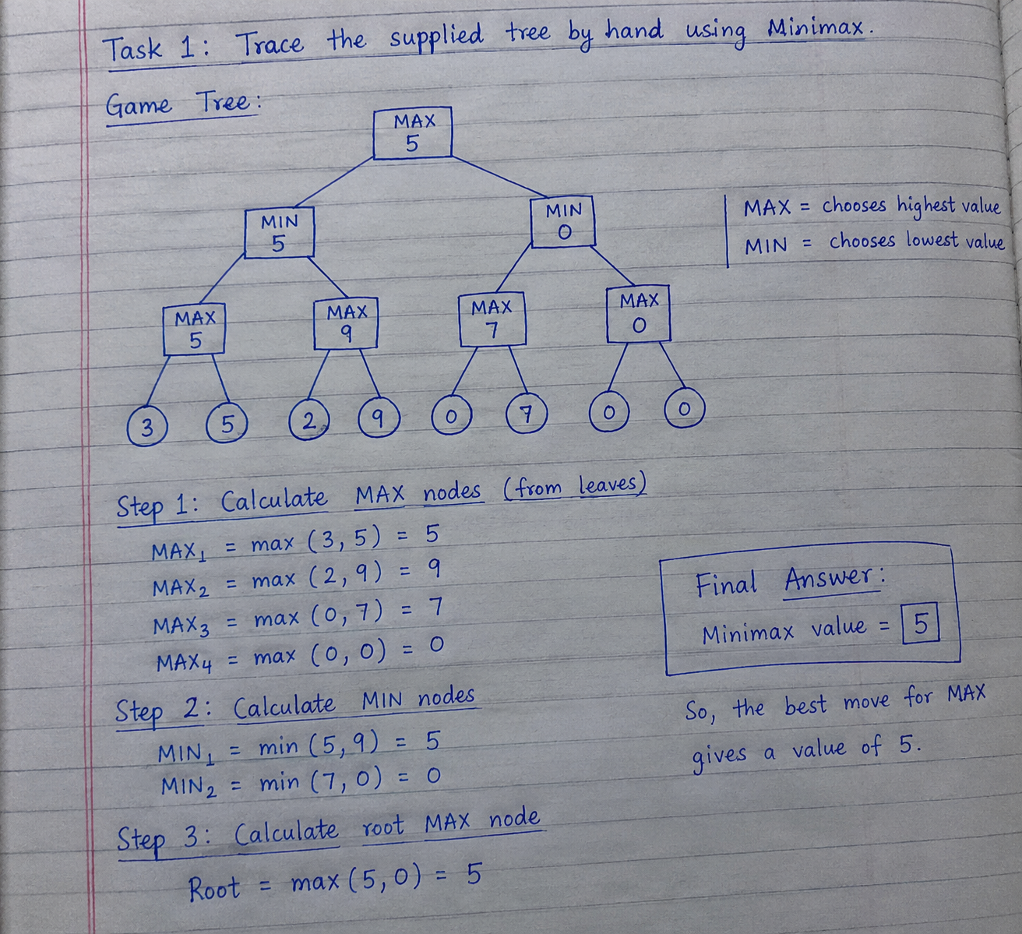

Task 2: Leaf-Evaluation Counter
1. Minimax: Minimax finds the best value by checking all leaf nodes.
2. Alpha-Beta Pruning: It gives the same result but skips some unnecessary leaf nodes.
3. Leaf Counter: leaf_count counts how many leaf nodes are evaluated.
4. Results: Minimax evaluates 8 leaves, while Alpha-Beta evaluates 6 leaves.
Both algorithms return the same value, 5. Alpha-Beta Pruning is more efficient because it evaluates fewer leaves.
Task 3: Reorder Branches and Observe Pruning
I changed the order of the leaf values and ran both algorithms again.
In the original order, Minimax evaluated 8 leaves and Alpha-Beta also evaluated 8 leaves. After reordering the branches, Minimax evaluated 8 leaves while Alpha-Beta evaluated only 6 leaves.
Both algorithms returned the same Minimax value of 5. This shows that branch ordering affects pruning efficiency but does not change the optimal result.

